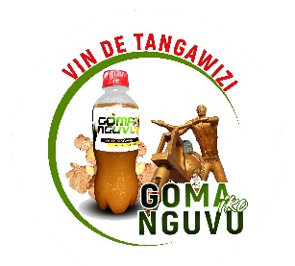
GOMA IKO NGUNI
Goma ,DRC
E-mail:ishimwej75@gmail.com
Tel: +243999560789, +243846191331

WORK SERVICE CERTIFICATE
This is to certify that Mr. HITAYEZU Jean Pierre was employed at Goma Iko Nguni as a Laboratory Technician in our Food and Beverage Department from 8th/01/2022 to 31th/02/2025, completing a period of three (3) years of continuous service.
During this time, Mr. HITAYEZU Jean Pierre was actively involved in:
Conducting quality assurance and quality control tests on raw materials, in-process products, and finished goods.
Performing microbiological, chemical, and physical analyses as per industry standards and regulatory requirements. Maintaining strict hygiene and safety protocols in compliance with HACCP, ISO 22000, and other food safety standards. Operating, calibrating, and maintaining laboratory instruments and equipment. Documenting test results accurately and preparing comprehensive laboratory reports. Collaborating with production and Research and development teams to ensure product consistency and compliance.
Mr. demonstrated a strong work ethic, technical expertise, and a high degree of professionalism throughout their service. He has been a valuable part of our quality assurance operations and have contributed positively to the company’s commitment to product excellence and safety.
We thank Mr. HITAYEZU Jean Pierre for their service and wish them continued success in their future professional endeavors.
Issued on: 05th/03/2025
At: DRC,Goma
ISHIMWE Jotam
Director Manager of GOMA IKO NGUNI

